**Database Design**

**NASA EVA Gamification**

*Group 3*

**Prepared By**

Jacqueline Macfadyen

Victoria Guadagno

Okechukwu Ogudebe

Michael Salgo

Kevin Fortier

Table of Contents

Overview 3

Specific Terms and Acronyms 3

Hardware and Software 3

Diagram Tool 3

Database 3

SQL Editor 3

DDL and DML 3

ERD 4

Relationships 4

Cardinalities/Business Rules 4

Entities 4

Assumptions and Special Considerations 5

Statements 5

Gamification_badges 5

Results 7

Gamification_badges 7

|  |  |  |  |
| --- | --- | --- | --- |
| **Version Number** | **Description of Change** | **Author** | **Date** |
| 1.0 | Initial Creation of Document | Jacqueline Macfadyen | 03/10/2018 |
| 1.1 | Revised Document Structure | Victoria Guadagno, Michael Salgo | 03/11/2018 |

# Overview

The database described in this document will augment the default MediaWiki database to allow for the gamification of the NASA EVA MediaWiki. The database will store the values necessary to track badges earned by users. The badge table will store details about the badge, the user and when it was earned.

# Specific Terms and Acronyms

|  |  |
| --- | --- |
| **Term/Acronym** | **Description** |
| SQL | Structured Query Language |
| DDL | Data Definition Language |
| DML | Data Manipulation Language |
| ER Diagram | Entity Relationship Diagram |

# Hardware and Software

## Diagram Tool

Lucidchart online tool for diagramming.

## Database

MariaDB 10.1.30

MariaDB is platform independent and will run on Windows, Mac, or Linux. PhpMyAdmin was used to interface with the database.

## SQL Editor

Sublime Text Editor for the Mac.

## DDL and DML

SQL will be used for the DDL and DML. The information captured in the ER diagram will be used to generate SQL scripts to create the database tables. In addition, SQL will also be used to create DML scripts to insert data to be used for testing.

# ERD

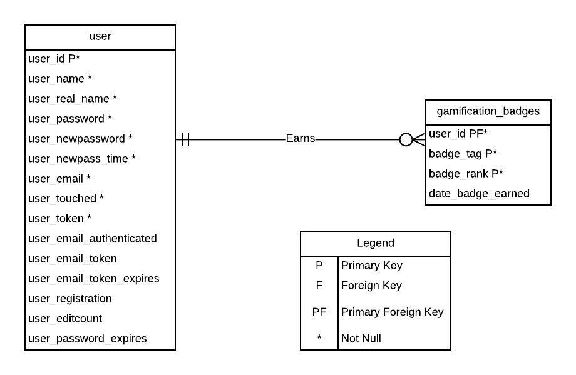

# Relationships

There is a 1:M relationship between user and gamification_badges.

# Cardinalities/Business Rules

A user can have zero to many gamification badges; a gamification badge is created for one and only one user.

# Entities

1. Entity Name: user

Entity Description: registered users in the MediaWiki database

Main attributes of user:

Attribute Name: user_id [Primary Key]

Attribute Description: auto incremented user id

Attribute Name: user_name

Attribute Description: user’s screenname

Attribute Name: user_real_name

Attribute Description: user’s real name

Attribute Name: user_password

Attribute Description: user’s password

Attribute Name: user_newpassword

Attribute Description: user’s new password

Attribute Name: user_new_pass_time

Attribute Description: datetime user’s new password was generated

Attribute Name: user_email

Attribute Description: email address of user

Attribute Name: user_touched

Attribute Description: last time user logged in

Attribute Name: user_token

Attribute Description: user’s token (if applicable)

Attribute Name: user_email_authenticated

Attribute Description: datetime user’s email was authenticated

Attribute Name: user_email_token

Attribute Description: token for user’s email (if applicable)

Attribute Name: user_email_token_expires

Attribute Description: datetime user’s email token expires (if applicable)

Attribute Name: user_registration

Attribute Description: datetime user registered on site

Attribute Name: user_editcount

Attribute Description: number of times user has edited a page

Attribute Name: user_password_expires

Attribute Description: expiration date of user’s password (if applicable)

1. Entity Name: gamification_badges

Entity Description: gamification badges earned by users

Main attributes of gamification_badges:

Attribute Name: user_id [Primary Key] [Foreign Key to user entity]

Attribute Description: user id

Attribute Name: badge_tag [Primary Key]

Attribute Description: badge tag

Attribute Name: badge_rank [Primary Key]

Attribute Description: badge rank

Attribute Name: date_badge_earned

Attribute Description: date badge earned

# Assumptions and Special Considerations

1. The date_badge_earned field will be populated when the badge is actually earned and null when the NASA EVA Gamification is installed for any retroactive badges that may be awarded.
2. Only one badge of the same tag and rank may be awarded to the same user.

# Statements

Gamification_badges

1. Create gamification_badges table

SET SQL_MODE = "NO_AUTO_VALUE_ON_ZERO";

SET AUTOCOMMIT = 0;

START TRANSACTION;

SET time_zone = "+00:00";

--

-- Table structure for table gamification_badges

--

DROP TABLE IF EXISTS gamification_badges;

CREATE TABLE gamification_badges (

user_id int(10) UNSIGNED NOT NULL,

badge_tag varbinary(255) NOT NULL DEFAULT '',

badge_rank varbinary(255) NOT NULL DEFAULT '',

date_badge_earned varbinary(14) DEFAULT NULL

) ENGINE=InnoDB DEFAULT CHARSET=binary;

--

-- RELATIONSHIPS FOR TABLE gamification_badges:

-- user_id

-- user -> user_id

--

-- Indexes for table gamification_badges

--

ALTER TABLE gamification_badges

ADD PRIMARY KEY (user_id,badge_tag,badge_rank),

ADD KEY game_badge_search_idx (user_id,badge_tag,badge_rank) USING BTREE,

ADD KEY gam_badge_user_idx (user_id) USING BTREE;

--

-- Constraints for table gamification_badges

--

ALTER TABLE gamification_badges

ADD CONSTRAINT gamification_badges_ibfk_1 FOREIGN KEY (user_id) REFERENCES `user` (user_id) ON DELETE CASCADE ON UPDATE CASCADE;

COMMIT;

1. Populate gamification_badges table with data from the user table for users with authenticated emails

INSERT INTO gamification_badges (user_id, badge_tag, badge_rank)

SELECT user_id, 'gamification-badge-emailverification', 'gamification-rank-1'

FROM user

WHERE user_email_authenticated IS NOT NULL;

# Results

Gamification_badges

1. Create gamification_badges table



1. Populate gamification_badges table with data from the user table for users with authenticated emails

